 

**EXPERIMENT REPORT OF ASSEMBLY LANGUAGE**

Assignment 2 Experiment 3

NAME : ABID ALI

STUDENT ID :2019380141

DATE : 5/22/2021

SUBMITTED TO :PROFESSOR Yin LU

**Problem Description:**

**Chapter 3 Experiment 2 Simple IO and Lantern Control**

(3) Input and out put with 8255.

Now we try to do input and output together.

In assignment 3, we change the led lights into a nixie tube, and 4 pin switches. The switches are connected with PortA.PA0 to PA3, and are used to input a single digit hex decimal number. This number should be displayed by the nixie tube. The nixie tube is connect with PortB of 8255.

You are required to write a program, input the number setup by the switches, then convert the number into a pattern code. And then, use the pattern code to light the nixie tube and display the input hex decimal number.

You can make use of the XLAT instruction to do the convert from hex into pattern code.

**Goal:**

The VMWare Virtual Machine WindowsXP with Emu8086 and Proteus was installed in my laptop.That was used in this experiment.

The led lights into a nixie tube and 4 pin switches that are in the circuit. The switches in the circuit we connect them with PortA.PA0 to PA3, and are used to input a single digit hex decimal number. The nixie tube is connect with PortB of 8255.

We wrote a program that,by press 4 switches can illustrate the Decimal number in the Nixie tube.The pattern code was provided by the teacher in the lecture and I followed that Pattern code to light the nixie tube and display the number into decimal number.

**NOTE:** We use the XLAT instruction to convert from hex into pattern code.

**Code:**

;===================================================================

;Description: Program of Assignment 2 Experiment 3

;Author:[ABID ALI][2019380141]

;Date:[05/22/2021]

;===================================================================

;This is the program for experiment 2 assignment 3

;change the led lights into a nixie tube

;===================================================================

.MODEL SMALL

.DATA

;THIS IS THE PATTERN TABLE

TABLE DB 3FH,06H,5BH,4FH ;DISPLAYING 3FH=0,06H=1,5BH=2,4FH=3

DB 66H,6DH,7DH,07H

DB 7FH,6FH,77H,7CH

DB 39H,5EH,79H,31H

.CODE

.STARTUP

MOV DX, 46H

MOV AL, 90H

OUT DX, AL

TOP: ;TOP IS A LABEL AND WE ALSO THE PROCESS

;TODO;PORT A

MOV DX, 40H

IN AL, DX

AND AL, 0FH

MOV BX,OFFSET TABLE ;THIS IS THE OFFSET PART OF THE PATTERN TABLE

XLAT

;TODO;PORT B

MOV DX, 42H ;PATTEN TABLE CODE IS OUTPUTED

OUT DX, AL

JMP TOP

.EXIT

END

**Explanation:**

At first,we made the pattern table for the Nixie tube

TABLE DB 3FH,06H,5BH,4FH ;DISPLAYING 3FH=0,06H=1,5BH=2,4FH=3

DB 66H,6DH,7DH,07H

DB 7FH,6FH,77H,7CH

DB 39H,5EH,79H,31H

**CODE BODY:**

MOV DX, 46H

MOV AL, 90H

OUT DX, AL ; Output byte in AL to I/O port address in DX.

Then,we move 46H in 16 bits DX register also we move 90H in 8 bits AL register .

This process happened , Output byte in AL to I/O port address in DX.

**LOOP:**

Then,we create a loop named “TOP”,

In the “TOP” loop, we have created the function of two port ,PORT A and PORT B

**PORT A:**

**;TODO;PORT A**

MOV DX, 40H

IN AL, DX

AND AL, 0FH

MOV BX,OFFSET TABLE ;THIS IS THE OFFSET PART OF THE PATTERN TABLE

In between there is a XLAT instruction,

XLAT − Used to translate a byte in AL using a table in the **memory**

**PORT B:**

;TODO;PORT B

MOV DX, 42H ;PATTEN TABLE CODE IS OUTPUTED

OUT DX, AL

Then,there is a JMP TOP instruction ,It goes from bottom to the top.

**Result:**

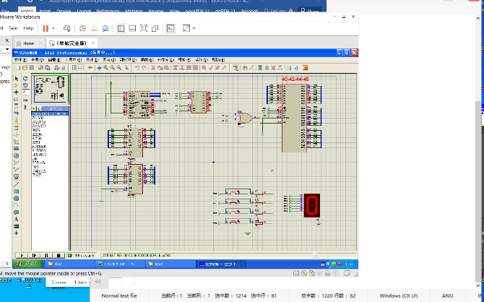

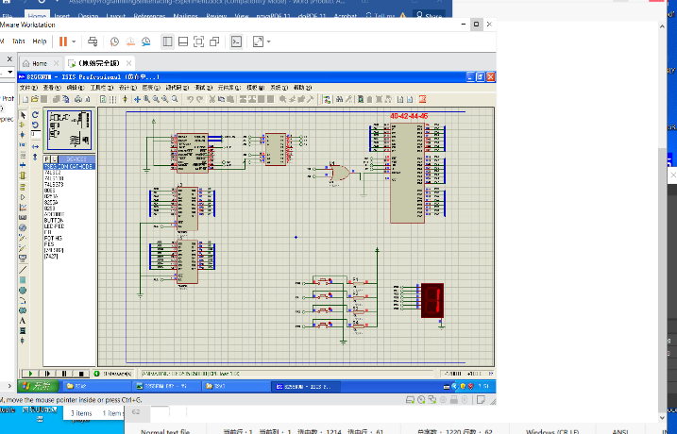

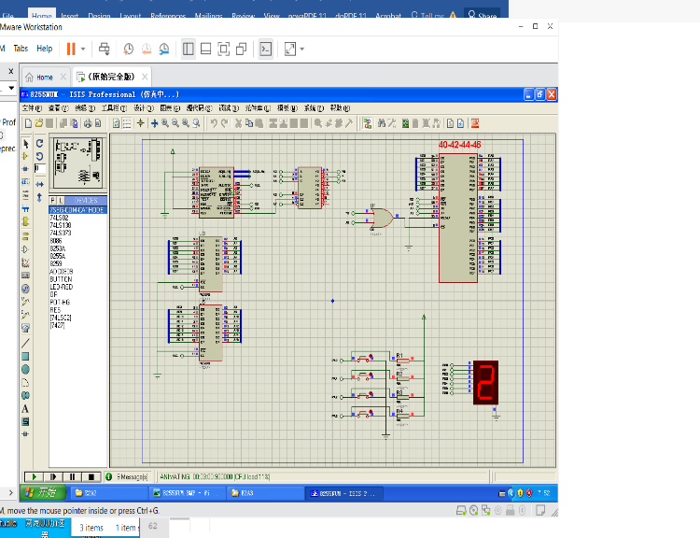

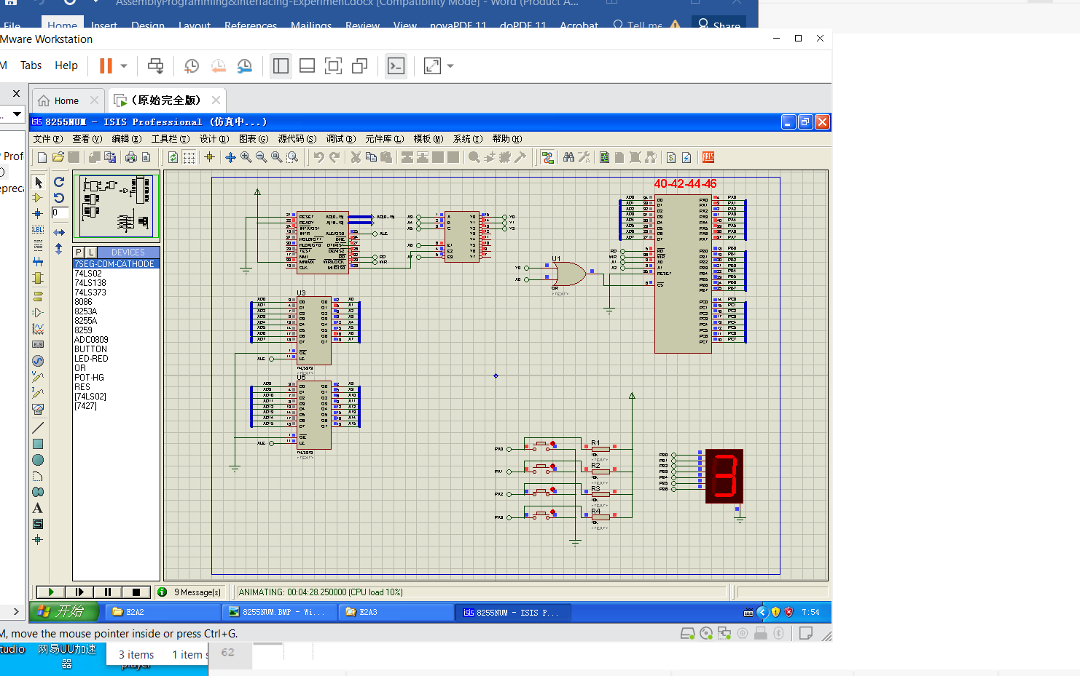

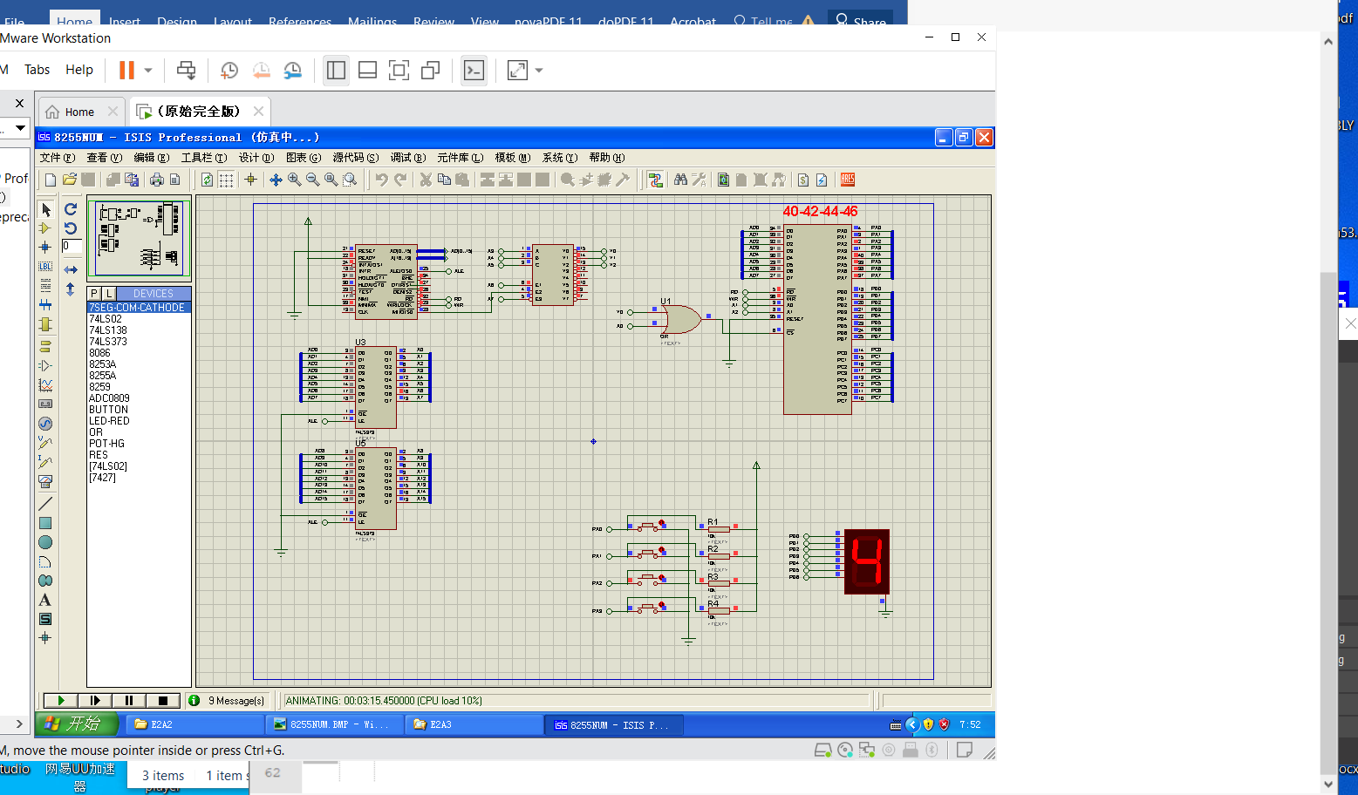

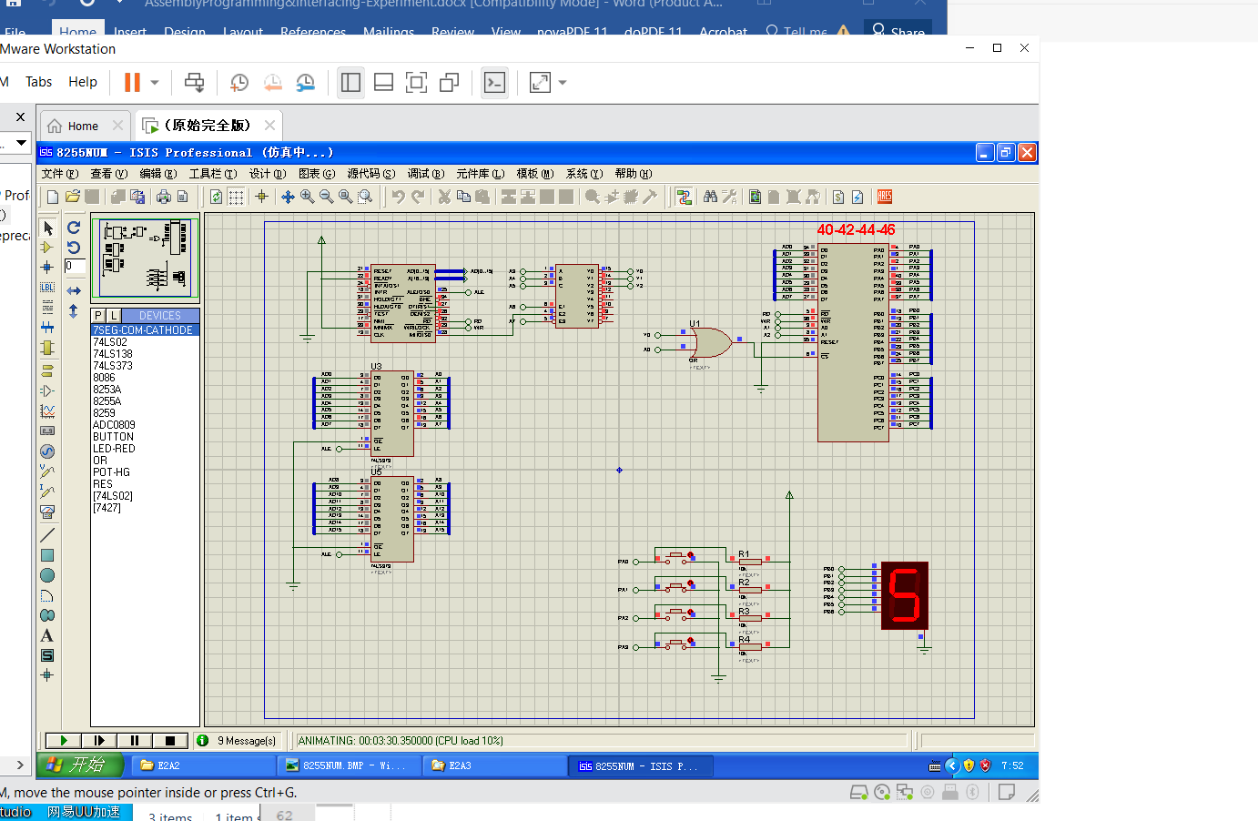

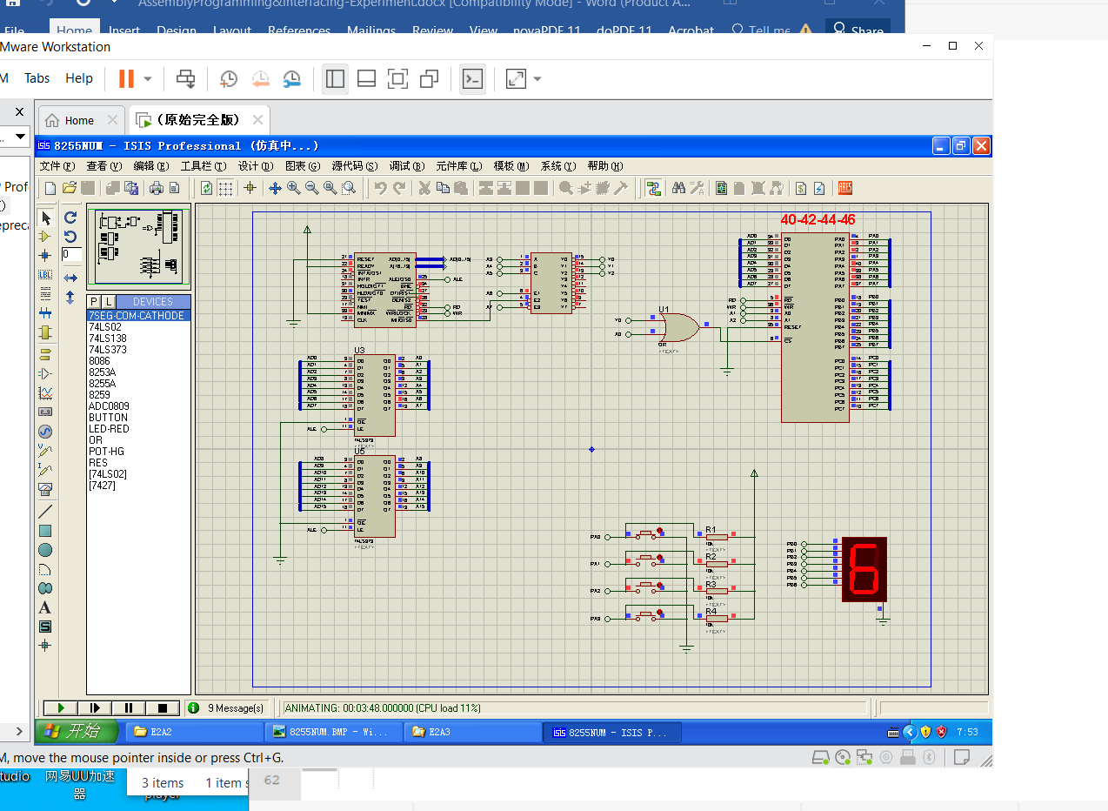

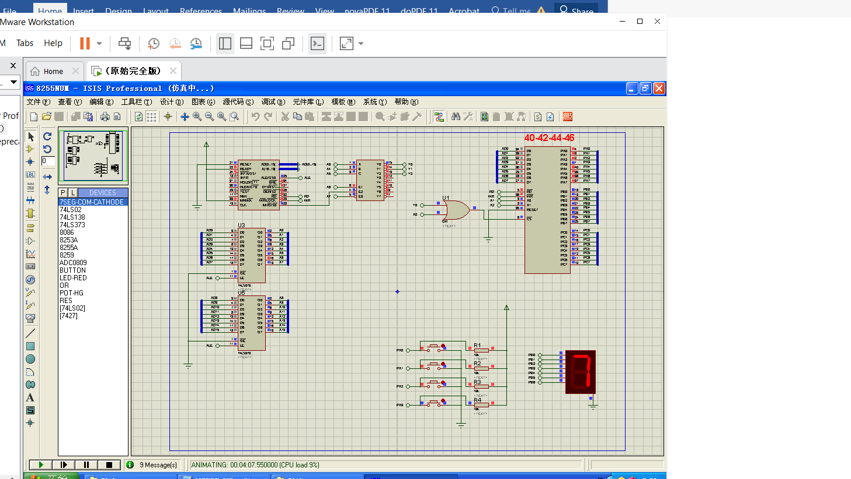

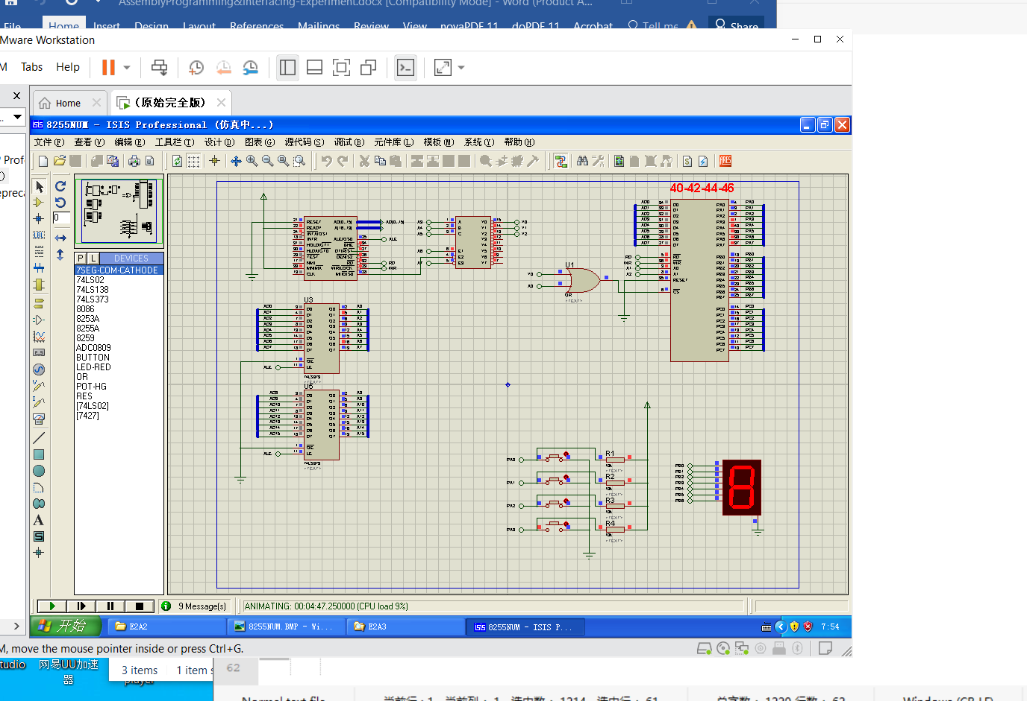

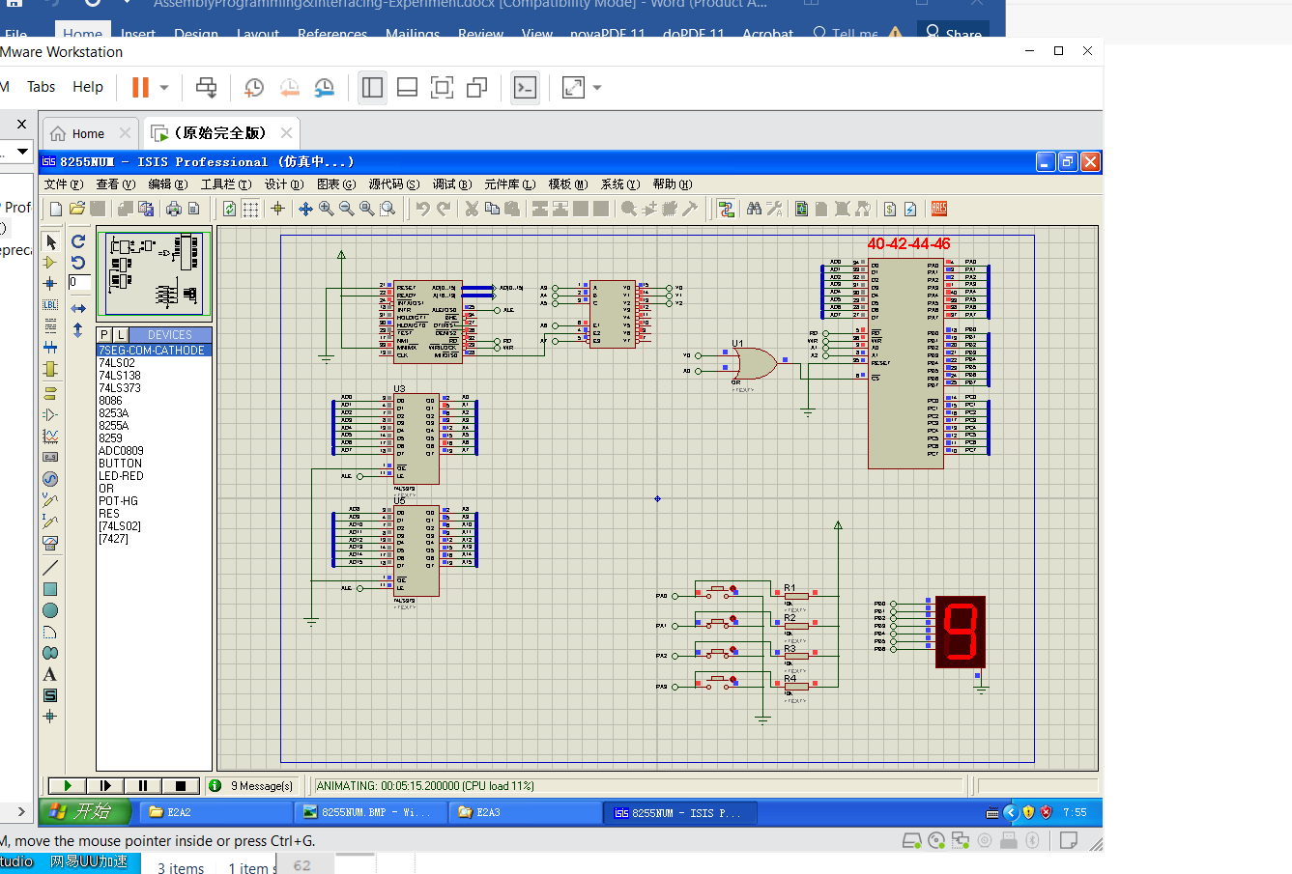

This are the decimal number ,I got after turning ON and OFF the red button.It acted like a switch.

**Debugging:**

This is a new IDE for me ,I have never used it before .So,at the beginning ,I couldn’t understand the use of so many features.Eventually,after watching video and reading the pdf given by the teacher .The biggest problem was to VMware software and proteus 7.After spending lot of time ,I understand how to use it.

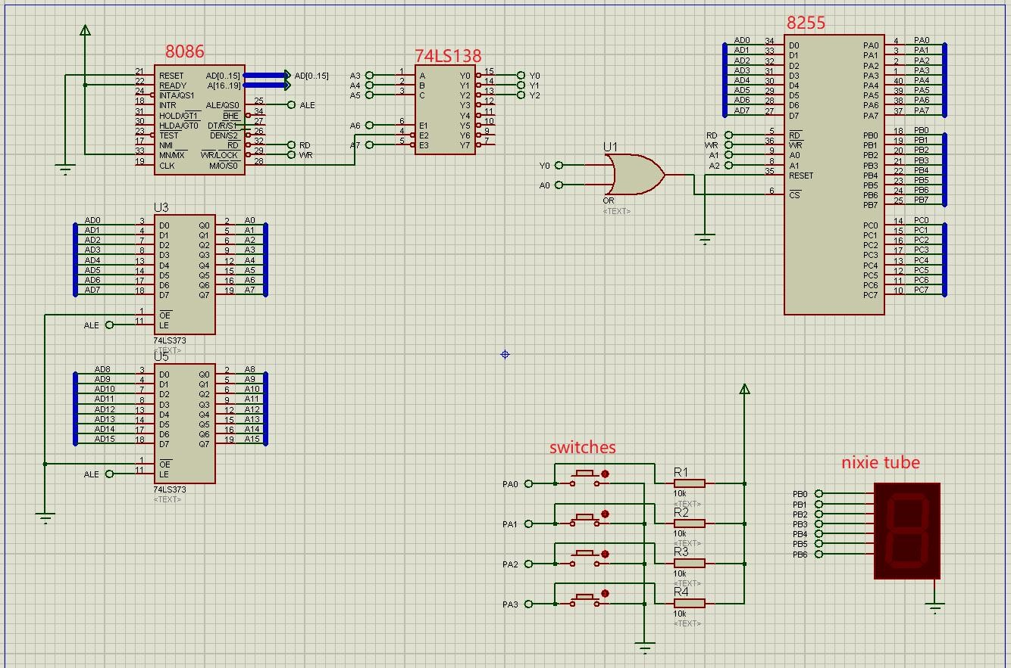

**Attachment:**

1) Experiment-2(assignment-3).m4v

2) Exp-2_ assignment 3.asm

3) Experiment-2(assignment-3).pdf

**Acknowledgement:**

I complete this assignment by myself by using online videos and taking help from online.The most useful help from teacher’s hint given in question ,the theory class and the lecture note from the practical class.